# **Product Sense -**

# How to tackle product strategy and business acumen rounds in interviews?

## **Lecture Objective:**

How to address business acumen questions round :

* Analyzing a **metric change.** What’s a metric?
* **Defining metrics** to measure performance / success of a new feature / product.

## **Importance of product strategy & business acumen rounds -**

* Apart from building models, developing dashboards and reporting frameworks - One of the main responsibilities of a data scientist is to **extract insights from data** and **work with product managers and engineering teams** to deliver actionable plans to i**mprove the product.**
* Product sense is about **understanding all possibilities**, not finding one correct answer.

## **Example Questions:** Product Acumen / Business Acumen

* Why did Youtube’s traffic drop by 5%?
* How would you measure the success of the “Save Post” feature on Facebook?
* What metrics would you define to measure the health of the product search in Amazon?
* We have a dashboard tracking our metrics and the avg ETA is up by 3 min. How would you investigate this problem?

______________________________________________________________________________

**Flow of Discussion between CEO, Product Manager and Data Scientist.**

**CEO:** Good morning, team. I'd like to discuss the upcoming launch of our new feature. **Product Manager, could you provide an overview of what we're planning?**

**Product Manager:** Certainly, CEO. We're introducing a new in-app messaging feature that allows users to chat with customer support directly. This should **greatly enhance the user experience and improve our customer service.**

**Data Scientist:** That's great news. To ensure its success, **I suggest we monitor** user engagement and response times closely. We should **track metrics** like chat usage, response rates, and customer satisfaction.

**CEO:** Agreed. **Data Scientist, can you set up a framework to collect and analyze these metrics?** Also, are there any early insights you can share about user behavior in our app that might be relevant to this feature?

**Data Scientist:** I'll get the **data collection** in place. As for user behavior, we've seen that users tend to spend a lot of time on our help center articles, which indicates a need for better support options. This **new feature aligns well with that behavior**.

**Product Manager**: It's reassuring to hear that. We're planning to roll out the feature to a small segment of users first to gather feedback. **Data Scientist, do you have any recommendations for how we can structure A/B testing to measure its impact effectively?**

**Data Scientist:** Certainly. We should set up the **A/B test to compare user behavior and satisfaction between those with access to the new feature and those without.** This will help us gauge its impact on engagement and customer satisfaction.

**CEO:** Sounds like a solid plan. Let's move forward with this strategy, and once we have collected enough data, we can reconvene to evaluate the feature's performance. Thank you, team.

**Product Manager:** Thank you, CEO. We're excited about this launch and the positive impact it can have on our users.

**Data Scientist:** Agreed. Let's work together to make sure we're making **data-driven decisions** every step of the way.

______________________________________________________________________________

**Key responsibilities taken by the CEO, Product Manager, and Data Scientist in the above discussion:**

**CEO:**

* Setting the overall direction and vision for the company.
* Initiating the discussion and requesting an overview of the new feature.
* Agreeing to monitor user engagement and response times.
* Leading the decision-making process and giving final approval.

**Product Manager:**

* Providing an overview of the new in-app messaging feature.
* Highlighting the potential benefits of the feature for the user experience and customer service.
* Suggesting the rollout of the feature to a small user segment for feedback.
* Seeking recommendations on structuring A/B testing to measure the feature's impact effectively.

**Data Scientist:**

* Suggesting the need to monitor user engagement and response times.
* Recommending the collection and analysis of specific metrics related to the feature, such as chat usage, response rates, and customer satisfaction.
* Offering insights into user behavior in the app, such as users spending time on help center articles.
* Proposing the setup of A/B testing to compare user behavior and satisfaction between users with and without access to the new feature.
* Agreeing to work on making data-driven decisions and collecting relevant data.

These responsibilities reflect the different roles and expertise of the CEO, Product Manager, and Data Scientist in the context of launching a new feature and ensuring its success.

______________________________________________________________________________

## **Judgment Criteria & General Framework** -

## Keep this in mind when addressing business acumen questions.

* Judgment Criteria for Interviewers :
  + **Structure** - Demonstrate a systematic approach
  + **Comprehensiveness** - Covers all important aspects
  + **Feasibility** - Practical enough that it could be implemented realistically
* General Framework to keep in mind :
  + **Clarify**
  + **Plan**
  + **Conclude**

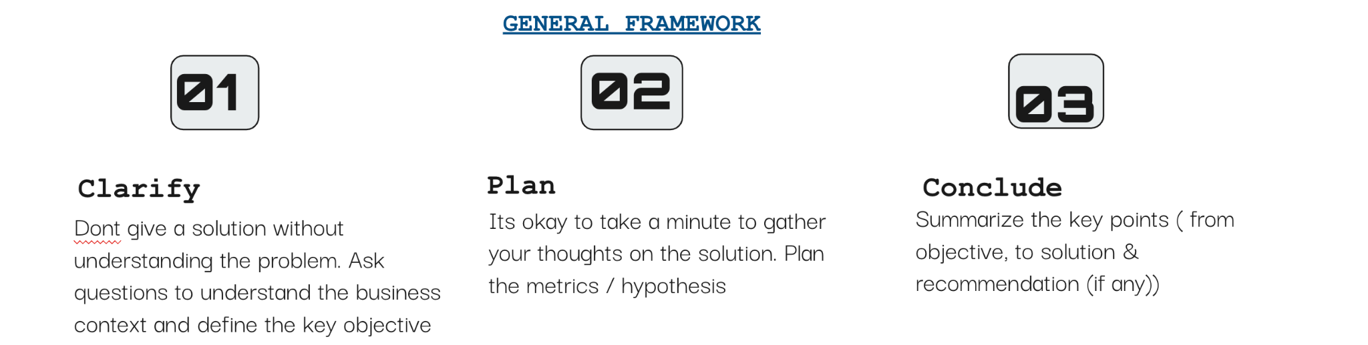

**Different Product Sense Problems** -

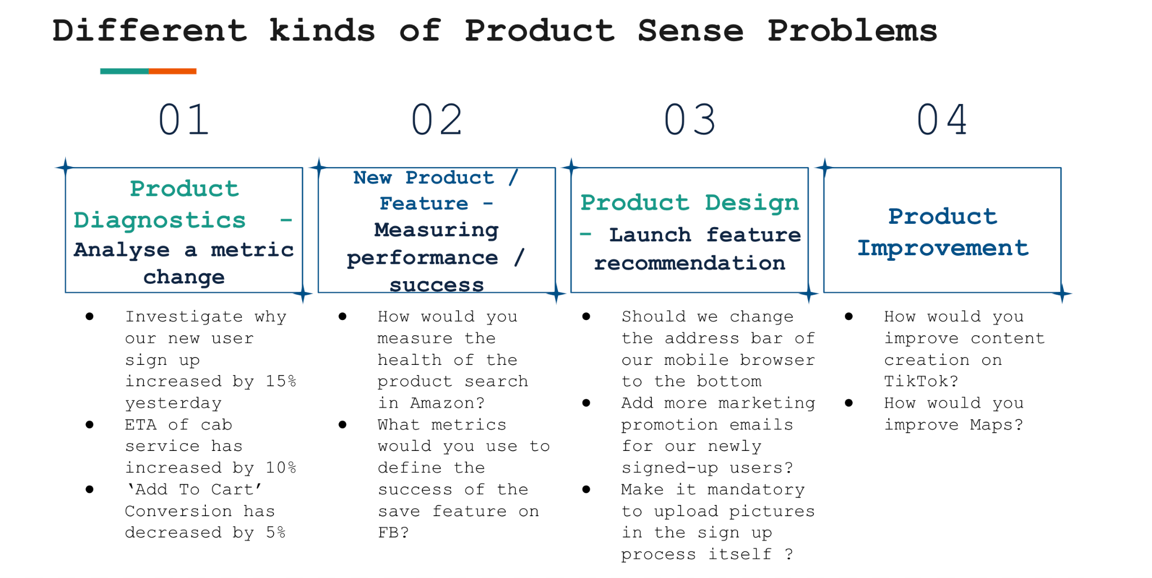

## 

## **Product Diagnostics - Analyzing a metric change.**

**Case -** You notice that the percentage of users who clicked on a search result about a Facebook Event increased 15% week-over-week. How would you investigate this?

**General Framework -**

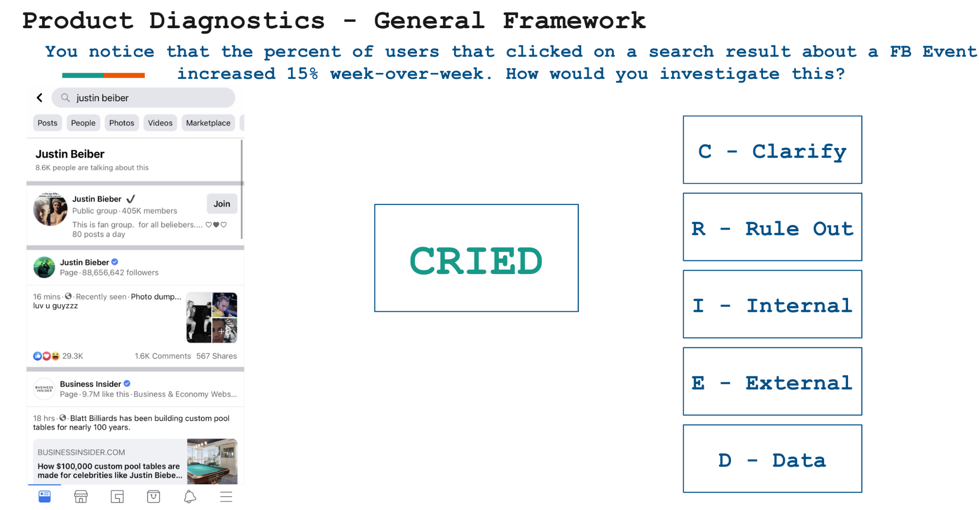

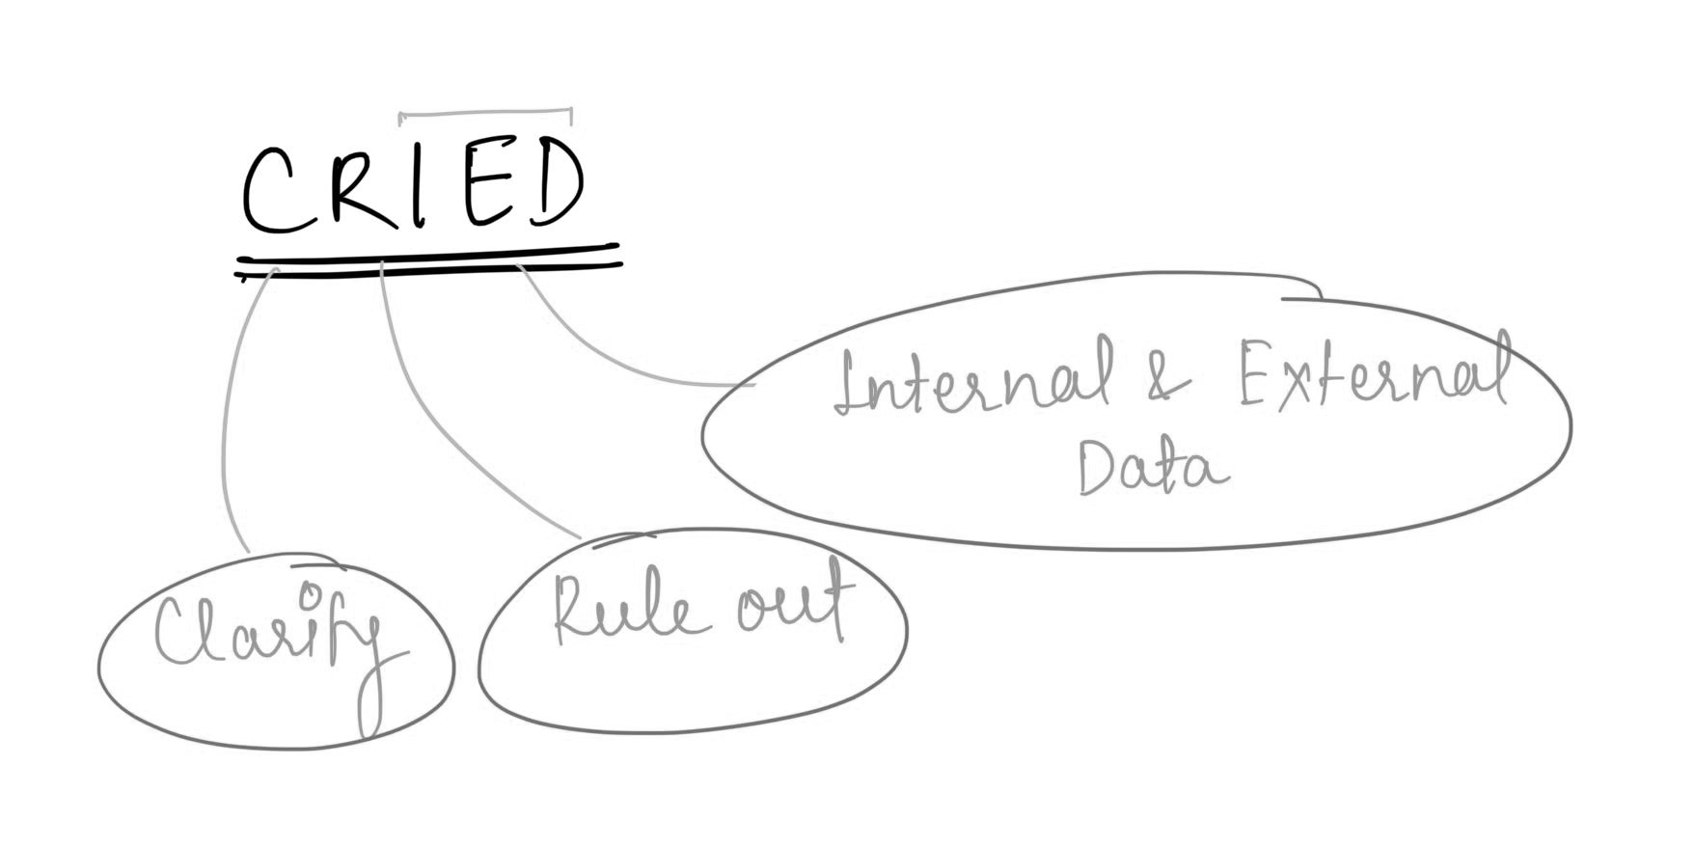

1. **Clarify:** Ask clarifying questions and share what your thoughts about it are.

Below is an example of how you could drive this with the interviewer.

* + What does a search result success for an event mean?
    - Does it refer to when a user searches for something in the search bar on Facebook and the results produce a Facebook event?
    - These search results could belong to different categories, like a Facebook Event, Page, or Group - and the success is defined when you click on the event
  + You could also clarify the definition of the metric in question.
    - 15% increase = # users who clicked on event result after searching / # of users who searched for any keyword.
    - 15% WoW = 15% increase in success rate compared to last week? Or there has been a 15% increase over the past few weeks.

1. **Rule Out:** Rule out any change in metric happening due to technical issues or infrastructural glitch / bugs or outliers.
   * Has there been any bug in the logging code because of which event clicks have been de-duped?
   * Is it a 3rd-party software tracking the search result clicks? If so, is there any glitch in that software?
   * Any data pipeline failure?
   * Ask about outliers - Did the metrics for the week get affected by one day’s data alone or has it been a consistent increase?
2. **Internal Data:** Explore the internal factors that could have affected the metric.

**Acronym: TROPiCS**

* + **T - Time:** 
    - Is this 15% increase seasonal / sudden / gradual?
    - **Sudden Increase** - could mean there is a bug in the logging of a new feature or update that's recently launched (ranking change?). This is creating problems so you may need to roll back.
    - **Gradual Increase** - may indicate a change in user behavior. Maybe users are starting to prefer live virtual events over physical events due to covid restrictions
  + **R - Region:** 
    - Is this change concentrated in a specific region or is it evenly distributed globally?
    - For example, we are slowly coming out of the pandemic and some cities have started to reopen. In which case, the rising interest in events may only be concentrated in those cities that are not re-opened
  + **O - Other related features affected:**
    - If an interest in events is going up, do we see a similar jump in Instagram or Facebook stories because users attending these events will have more content to post about?
  + **P - Platform:** 
    - Are we seeing this increase across both Android / iOS?
    - Across Mobile / Desktop?
    - Across Mac / Windows?
    - If only one of them is seeing an increase, we should explore if there’s an engineering bug with the platform that has caused a glitch
  + **C - Cannibalization:** If the metric for a product is decreasing, is it because another product we offer is cannibalizing engagement?

Alternatively, if the metric in question is increasing, are we cannibalizing from our other offerings?

* + - Around the time when the spike in event clicks happened, are we seeing a decrease in # clicks on profiles/pages / groups?
    - Is there a specific category that we’re cannibalizing from or is it evenly distributed?
    - For instance, is it only users that previously clicked on Groups (not Pages) that are clicking on Events now?
      * This may indicate that we made a change to the ranking of Groups in our search results.
      * Did we down rank it? Or accidentally remove it completely?
  + **S - Segmentation:** Slice and dice the data to identify the demographic of users this increase has affected.
    - **Age -** Are we noticing this increase only amongst teenagers / young adults / middle age or senior users?
    - **Gender -** Is this increase only among female users? Or across both genders
    - **Power Vs Casual Users -** Are we observing this increase only among those users that are less active on FB?
    - **New Vs Existing Users -** Are we observing this increase only among those users that recently joined FB? Are the existing users still exhibiting same behaviors

1. **External Data:** 
   * Industry/Competitor
     + Did the # of users attending events on Twitter decrease?
     + A new competitor has joined the market.
     + Are competitors changing their offering?
   * Good PR
   * It could also be due to seasonality or a major temporary event.
     + If it’s a major temporary event, you should see KPIs begin to return to their normal state shortly.

## **2. Measure Product Performance / Success - Defining metrics**

**Case -** PM reaches out to you after launch of a new save feature on Facebook to assess the success of this feature. Define the metrics you would like to measure.

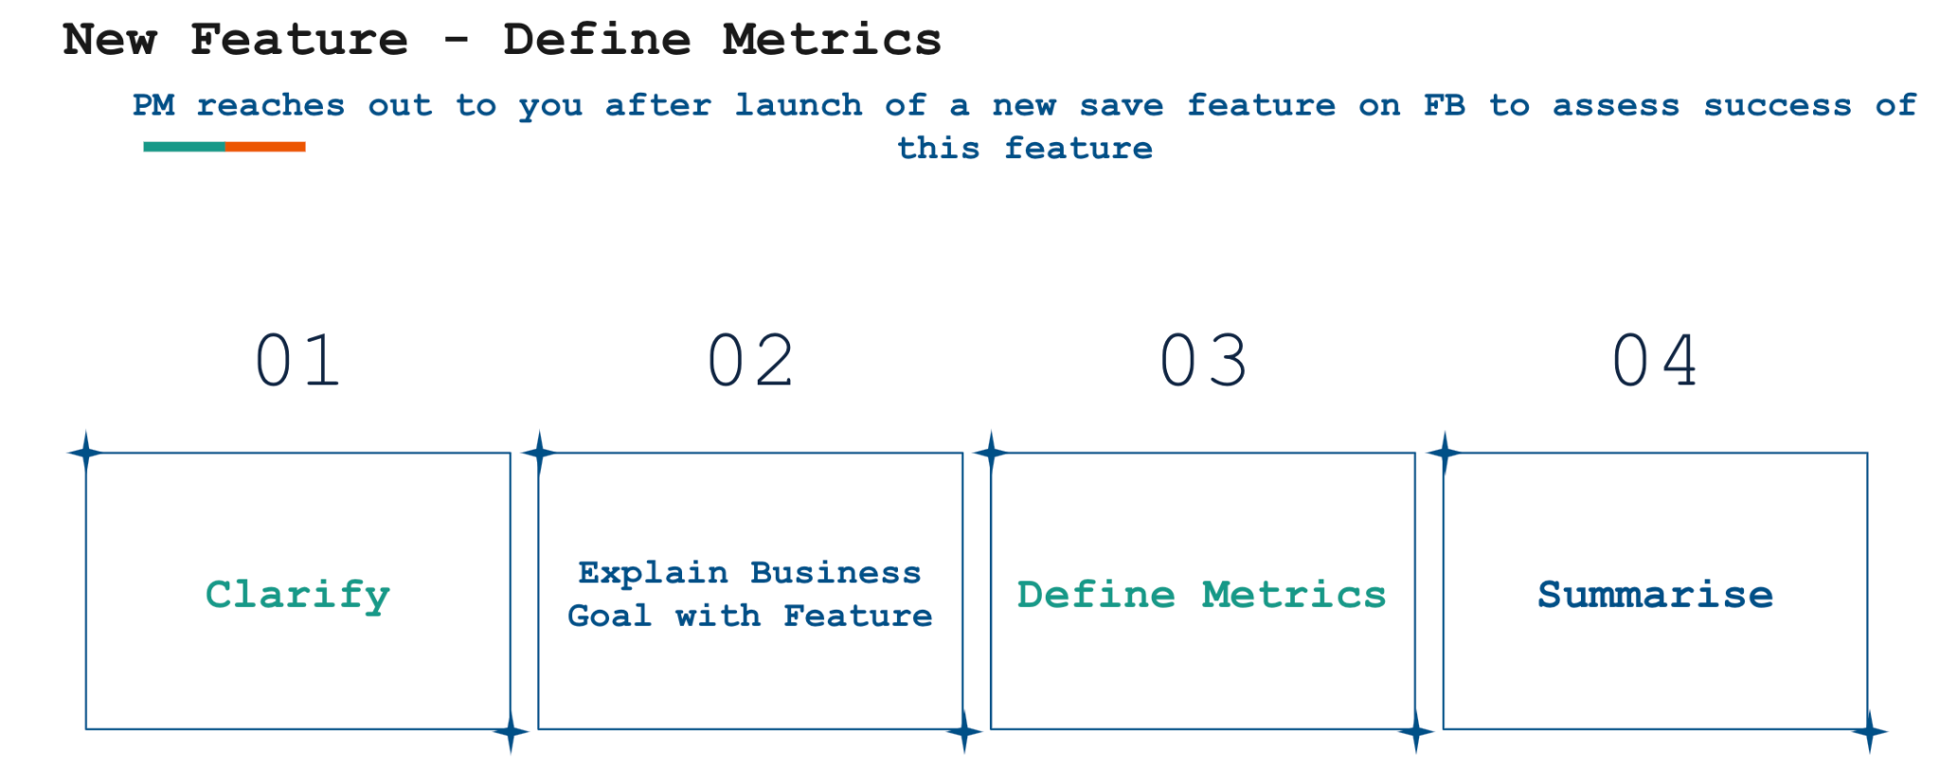

1. **Clarify:** Ask clarifying questions about the new feature / product and the main objective behind its release (monetization, engagement, retention etc).
   * Is this save feature used to allow users to Save Links, Pages, Posts, Locations, Movies, etc. to view later?
   * Does this also remind users about what items they have saved later?
   * Are we focusing on both aspects of this feature or only the first?

* **Who Benefits from This Feature:** This feature affects users and marketer?
  + **Marketers** do not want to be forgotten, so if they post something that attracts the attention of the user, they want the user to be able to find it again later if they don't have immediate time to spend on it.
  + For example, if there is a nice shoe advertised on FB and the user likes it, but cannot check it now, or there is a discussion about a TV series that the user potentially finds interesting to watch later, the user can save it to check it out later.
* **Business Goals:** 
  + **User Goal:** The benefit for users is that they do not need to copy paste or take a screenshot of the post they want to check out later. They can have all these items in a categorized way (e.g., Movies, Pages) and can check them later.
  + **Marketer Goal:** Increases revenue for marketers by increasing clicks and impressions.
  + **BIZ Goal:** Increases user engagement.
    - Increase revenue by increasing CTR, and CPC and CPM. Because the user might make a click that he would not have done otherwise if they could not save the post. So, the goal is to increase CTR and consequently the revenue.
* **Define Metrics:**

Please note that not all elements are applicable to all problem statements.

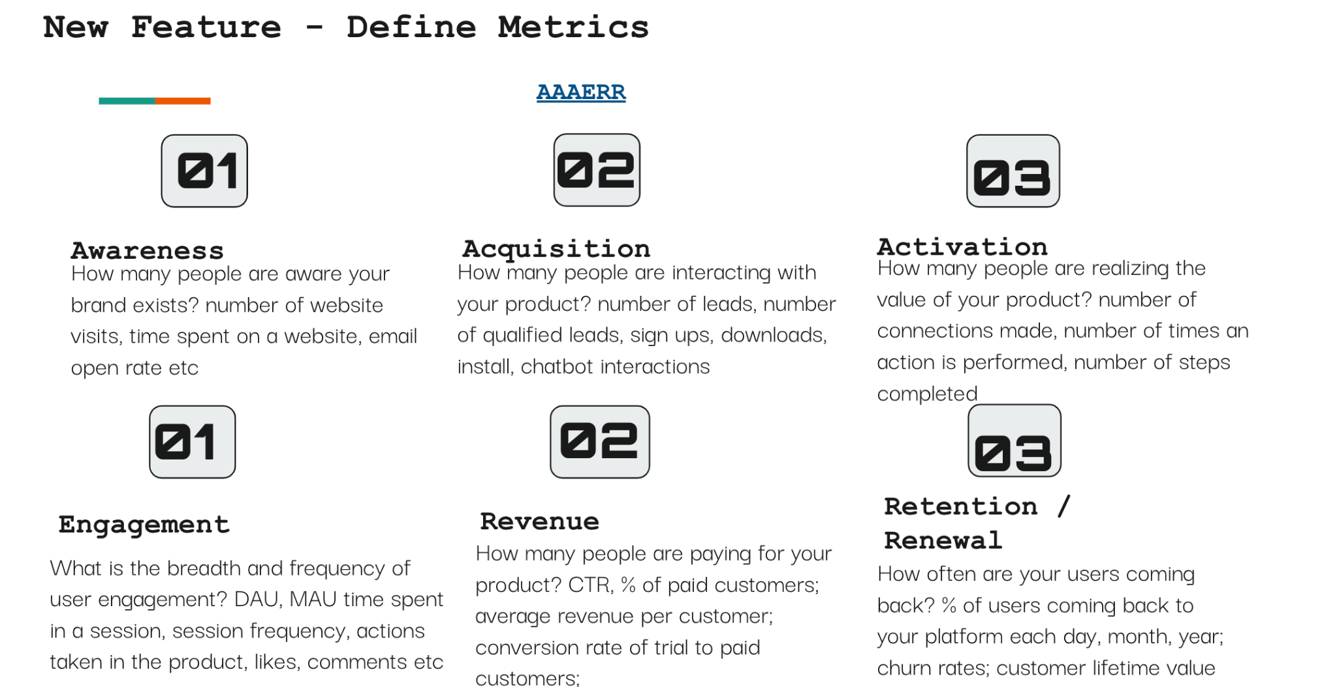

1. **Awareness:** 
   1. **Discoverability:**
      1. % of users the have at least once Saved an item
         1. This shows that the users know about this feature.
      2. # of returns to saved content per user
         1. % of users returning to view saved content organically (on their own) - User knows where to find Saved items and knows how to work with it.
         2. % of users returning inorganically (i.e., reminded by
         3. Facebook to view saved content).
2. **Acquisition:**
   1. # of new clients who want to advertise with Facebook.
   2. Increased spending of existing clients with Facebook since the launch of the save feature.
3. **Activation:**
   1. **Adoption:**
      1. % of total posts saved (# Saved Posts / # Total Posts)-Indicates the adoption rate of the save feature - # people using the save feature actively.
4. **Engagement:**
   1. Average number of likes, comments, shares per saved post on a daily, weekly, and monthly basis- indicates the user engagement on a broader level. Compare this with a general post with no save feature and see if the engagement is more with the new feature.
   2. %of Saved items that the user opens from the Saved page.
   3. Amount of time spent on a page, after opening it from the Saved page.
   4. The average amount of time it took a user from Saving an item to opening it again.
5. **Revenue:**
   1. % revenue increase just based on clicks and impressions made through the funnel that includes Saved items.
6. **Guardrail Metrics:**

(Along with success defining metrics, it's also important to define guardrail metrics)

* 1. Has the success metrics of other features gone down because of the launch of the save feature?
     1. For example, Although the save feature is leading to a lot of users saving the video, they fail to actually come back to the saved page and watch it. This reduces engagement in video content.
  2. %of Saved items that the user deletes without engaging with or opening them.

______________________________________________________________________________

**Product Metrics**

What are product metrics?

* Product metrics are quantifiable data points that a business tracks and analyzes to evaluate the success of its product.
* By using interactive product metrics, companies can optimize product strategies to ensure business growth.
* Determining the right metrics to monitor and analyze leads to more intelligent decision-making throughout the product development process.

What are KPIs?

* These metrics, sometimes called **key performance indicators (KPIs)**, give the company quantifiable evidence about which aspects of the product / customer experience are resonating with customers, and which aren’t.
* Product KPIs can be related to user requirements, size, quality, product growth, or user comfort.
* They can evaluate architectural measures, quality measures, software complexity, or functional size.

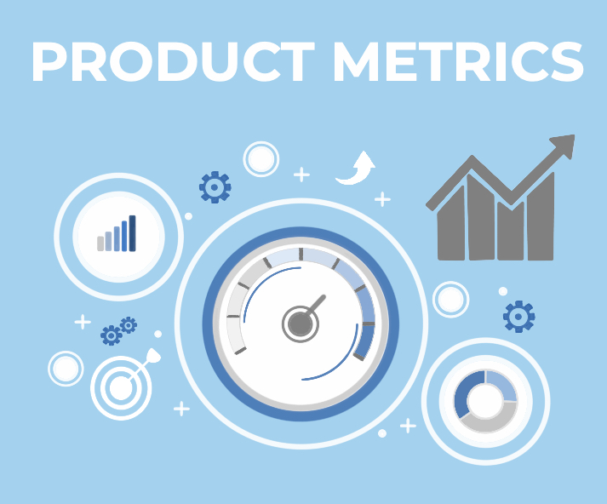

How do companies use these metrics?

Depending on their goals, companies may use product metrics to:

* Set their product roadmap
* Evolve product strategy
* Make changes to their product
* Forecast revenue
* Measure the impact of individual features
* Better understand user behavior
* Evaluate the success of a launch
* Segment their market
* Test product hypotheses

Why are they important from an interview perspective?

Metric definition questions come up very frequently in Data Science interviews.

These questions are generally meant to:

1. test your ability to understand the goal of a product,
2. trace the customer journey with that product and
3. map both the goal and the journey to a set of quantifiable measures.

Understanding different product metrics -

There is no fixed categorization of product metrics.

However, on a broader level, metrics are often categorized as either "**Vanity**" or "**Actionable**" based on their utility and relevance in guiding decision-making and strategy.

Difference between Vanity metrics and Actionable metrics:

| **Aspect** | **Vanity Metrics** | **Actionable Metrics** |
| --- | --- | --- |
| Nature | Superficial metrics that focus on showcasing positive but often superficial numbers. | Metrics that are relevant to the core goals and objectives of a business or product. |
| Emphasis | Prioritizing quantity over quality, may not provide meaningful insights. | Prioritize quality over quantity, focusing on critical data. |
| Actionability | Lack a direct connection to specific actions to improve performance or decision-making. | Closely tied to specific actions that can improve performance or outcomes. |
| Purpose | Sometimes called "ego metrics" as they can boost an ego with impressive numbers. | Goal-oriented and help organizations track progress toward achieving desired outcomes. |
| Examples | Total website visitors, social media followers, page views, downloads.  **e.g. A social media influencer might have 5M followers but when promotes a product, only able to get a CTR of 0.001%** | Conversion rates, customer acquisition cost, customer lifetime value, retention rates, revenue per user. |

Now, we will look at the three labels of metrics that a company follows in order to grow :

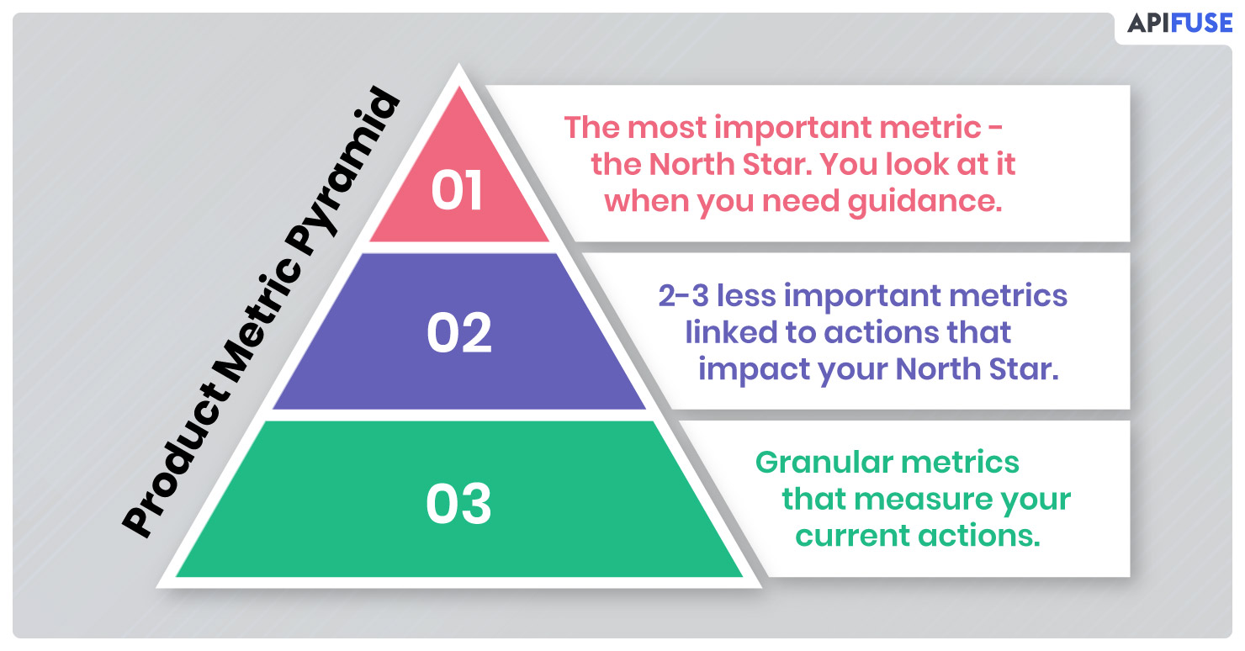

**Focus metric / North Star metric -**

This is the single most important measure of success that matters a lot to a company.

A North Star Metric (NSM) should be:

* A direct reflection of the company’s mission
* An indicator of how a company brings value to its customers.
* The only one of its kind. (Avoid having multiple NSMs as this tends to create complexity and confusion)
* The answer to the following question: What is the one metric that best represents the desired outcome of your company?

Which metric, if it were to increase today, would most accelerate my business’ flywheel?

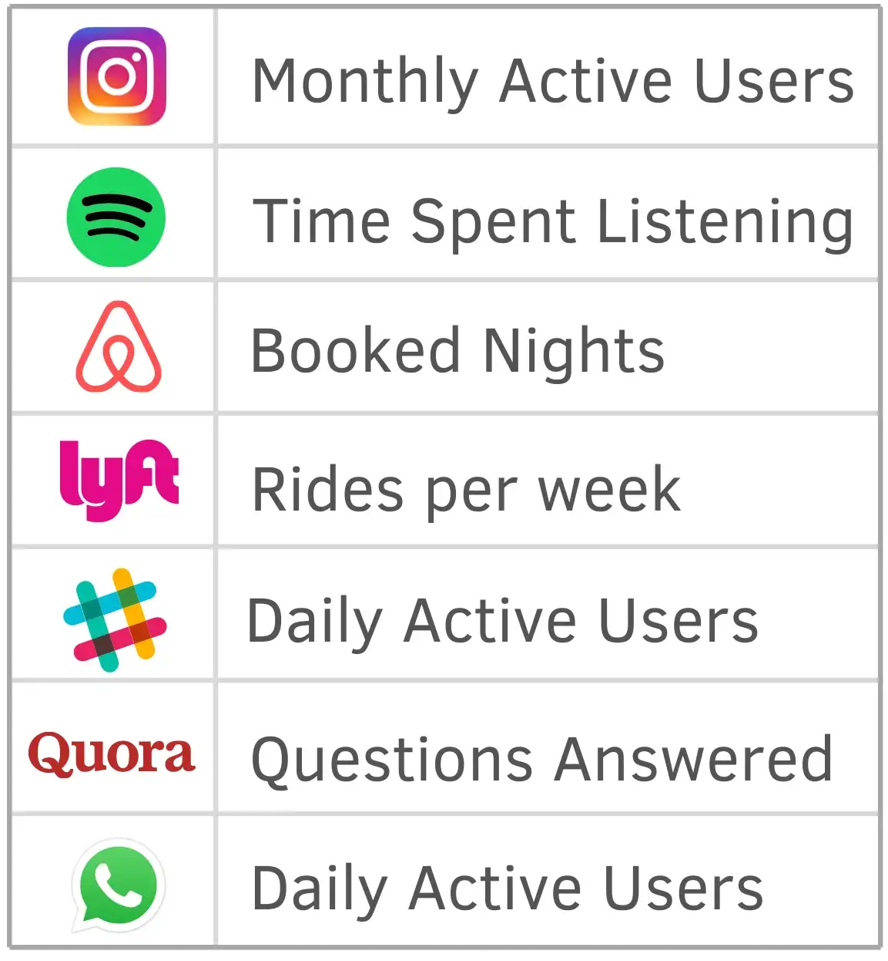

**Level 1 metric / Primary metric -**

* Primary metrics depict the desired outcome of a particular product, team, or initiative. This is unlike the NSM, which represents the desired outcome of the company as a whole.
* Level 1 (L1) or primary metrics should either directly contribute to the focus metric or act as a check to make sure the product is growing in a healthy direction.
* The primary metric can be more valuable than the NSM in the short-term because of its narrower focus, tighter feedback loop and more immediate association with the specific product, team, or initiative in question.
* For example, if a product’s focus metric is Weekly active user, a good L1 metric would be 7-day retention to ensure you aren’t spending precious marketing funds to acquire new users who leave after a day or two.

**Supporting/ Tracking/ Input metric / Level 2 metric -**

* Performance indicators which are set for the current initiatives that are most granular and mostly used for tracking the progress at lowest level.
* For example - There may be some targeted marketing or segmented offers that need to be checked.
* Supporting metrics are indicators that the primary metric is moving in the right direction.
* To take the retention example one step further, the Level 2 metric could be iOS app retention.
* Another could be a Level 2 metric such as the retention of a region or segment of customers.

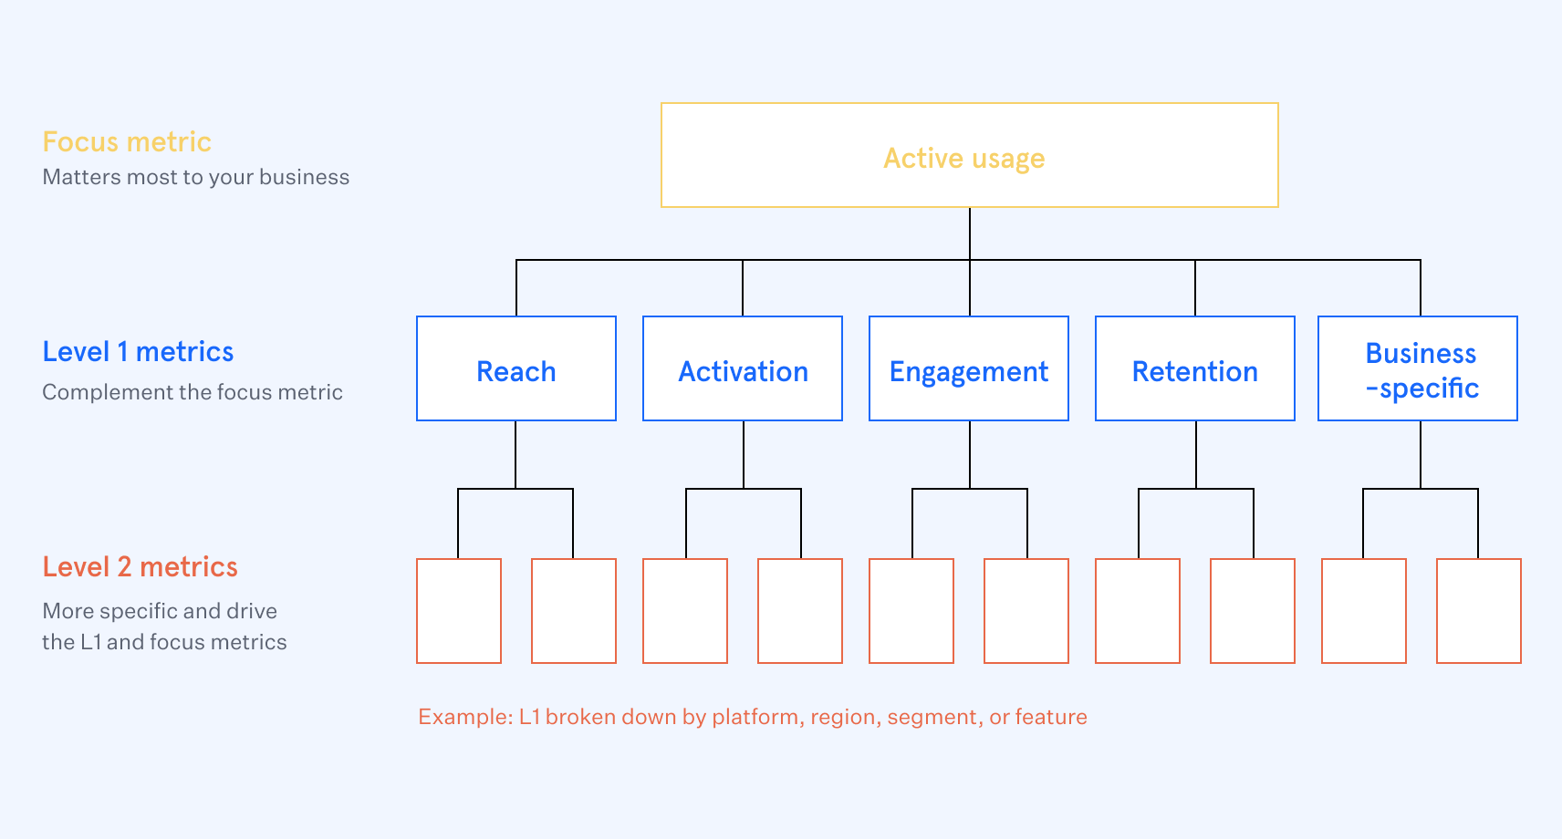

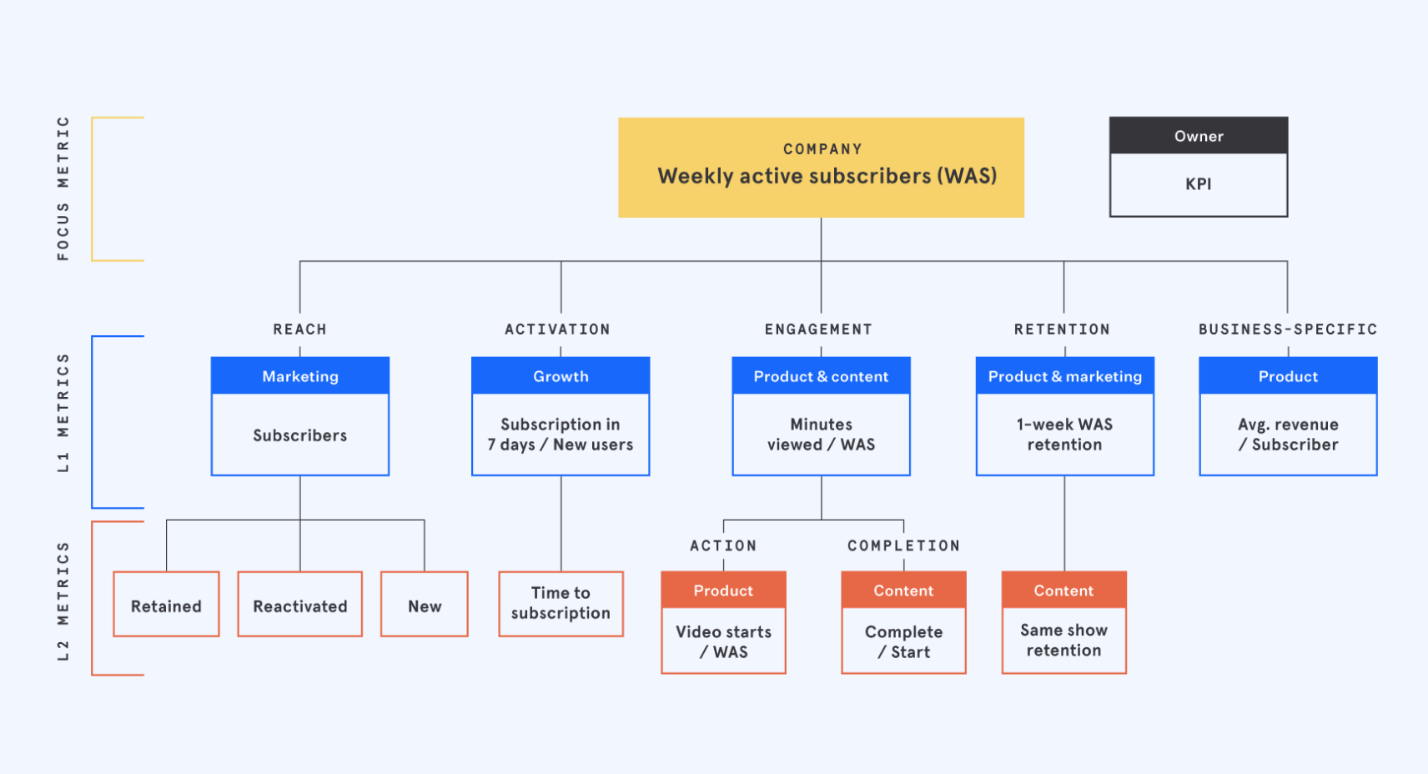

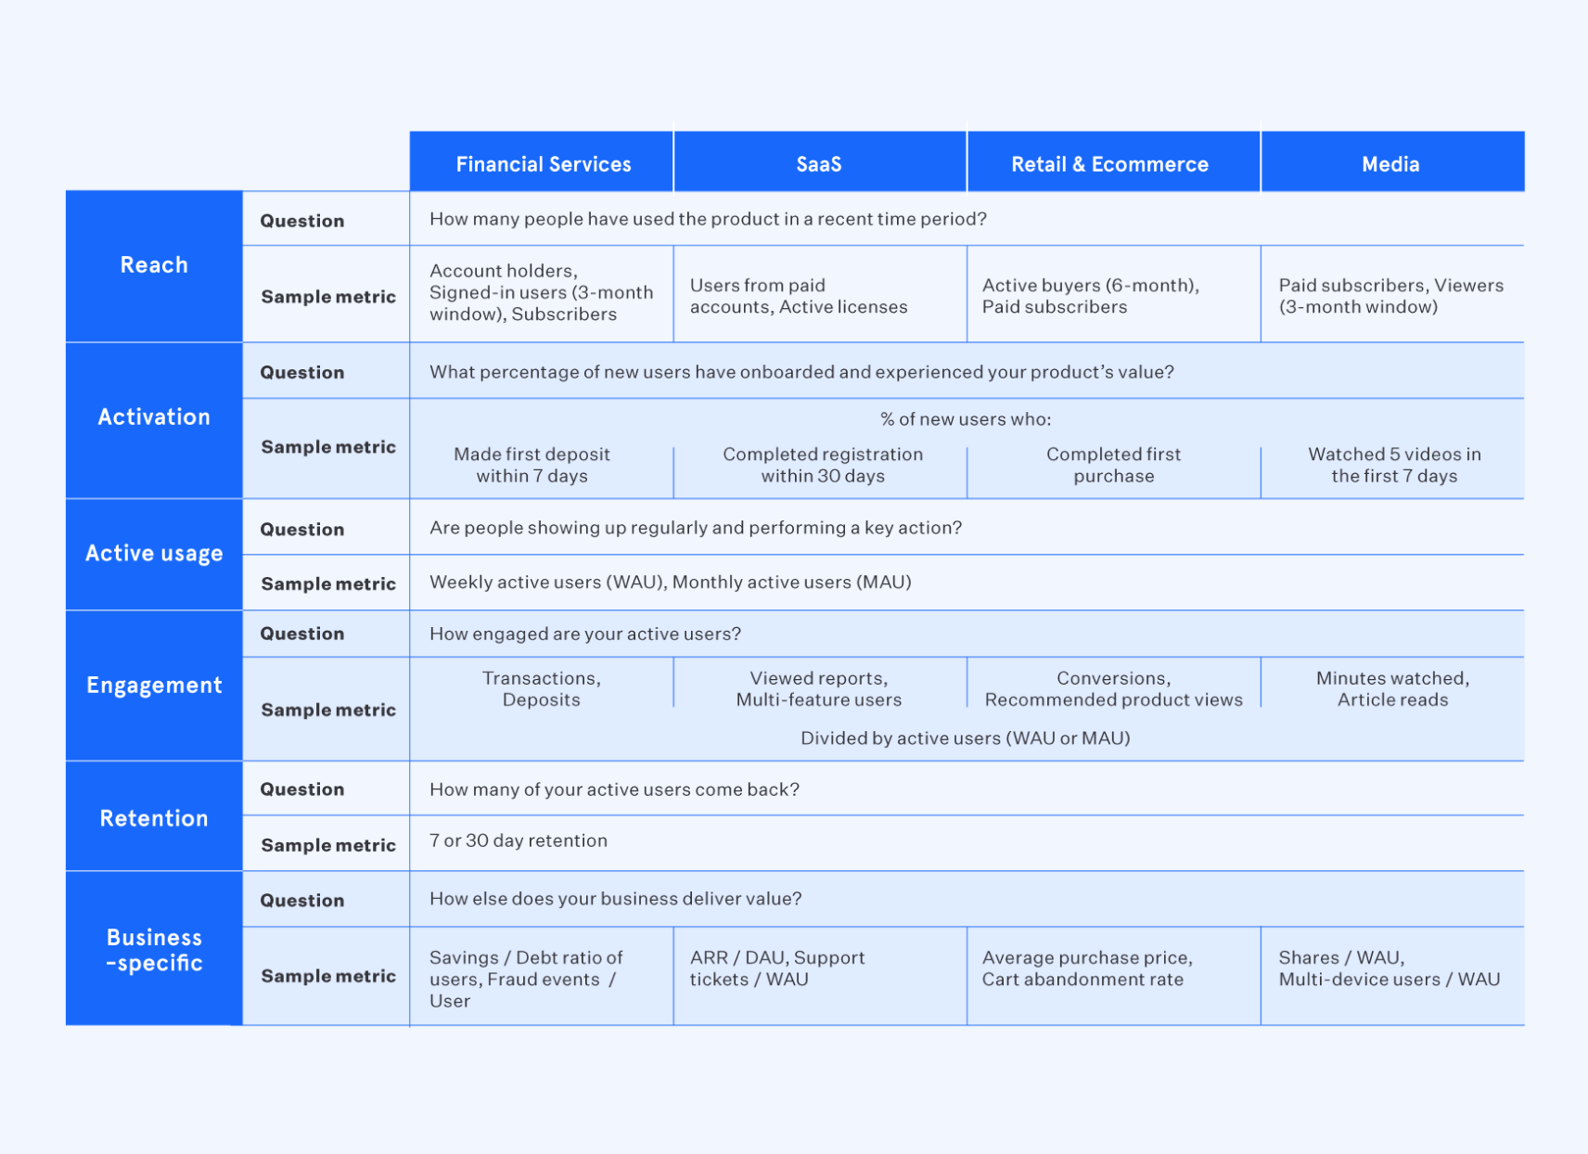

What’s a product metric interview question?

* Metric interview questions test if candidates can perform data analysis and select key metrics that matter most to the success of a product.
* Employers like Facebook and Google use these questions to evaluate critical thinking and communication skills.

There are two types of metric questions:

1. **Metric definition** based:

* Metric definition questions focus on your ability to define metrics that provide clarity on the health of a product or feature.
* Here’s an example question: “What metrics would you use to determine success for Facebook Sponsored Posts?”
* There are many different metrics you could be tracking (e.g., impressions, clicks, return on ad spend, etc.) and your interviewer will want to hear you select the most important ones using a rigorous process.

1. **Metric change** based:

* Metric change questions test if you know what to do when a key product metric (e.g., traffic, revenue, engagement, etc.) is going up or down for no apparent reason.
* This is almost the same as root cause analysis i.e.: an approach for identifying the underlying causes of an incident so that the most effective solutions can be identified and solved.

### We will be focusing on metric definition questions here -

Framework for working on such problems -

Here is how you can answer a metrics definition-based question:

1. Describe the feature.

* Explain your understanding of the feature, what problem it solves, and how it solves it.
* Clear if everyone is on the same page related to the problem and features.

1. Determine the goal of the feature.

* In a metrics question you are measuring the success of a feature in achieving a specific goal.
* Hence, it is crucial to have clarity on what that goal is.

1. Walk through the customer journey.

* Understand the funnel of the product and customer interaction.
* Walk through the user journey from beginning to the end of the interaction with the feature.
* This step also helps you think about potential behaviors that can impact the success of the feature.

1. Map and quantify user behaviors.

* Mapping user behaviors that are part of the customer journey and impact the goal of the feature in a positive or negative way.
* Examples of the customer journey phases a user can go through: Awareness, Acquisition, Activation, Engagement, Retention, Monetization, Referral. ​​
* Review the phase by highlighting various scenarios / behaviors and relevant outcomes that can have an impact on the goal(s) and explain why measuring the behaviors and (or) their outcomes is relevant.
* This step helps you determine what needs to be measured.

1. Evaluate your metrics.

* Now that you have gathered a list of metrics that impact the goal, evaluate them based on some meaningful criteria such as reach, impact, confidence, and effort.

**CASE 1:**

What metric would you look at, to improve retention for a fitness application?

________________________________________________________________

**Problem Statement:**

There’s a fitness company “PureFit”, who has launched their new application that has various fitness related information like videos and information on how to perform certain exercises, diet management plans, etc.

They also have classes and live sessions for users to join and follow.

There are two types of customers:

1. **Free customers** that have access to certain videos and information, nothing customizable.
2. **Paid customers** that can get personalized diet plans and advice from experts with respect to their fitness goals.

Here what we look at is based on our business model and user behavior.

We look at a **retained user who has been with us for at least two months.**

If they fall off before two months, then we don't call them as a retained user.

So basically, that a user has been using the app for more than two months.

Now that we have a fair idea of the problem and if we just look at the funnel for a user joining a fitness app it could be:

* There's an **acquisition stage** where we are trying to acquire the users.
* Then there’s an **onboarding stage** where users have signed up and logged in.
* Now next comes the **engagement part w**herein they're browsing what all the app has to offer i.e., they're doing the classes looking at a bunch of videos.
* Finally, if they're **coming back on the platform** again and they're continuously using it for two months that is what we are qualifying as retention.

At this stage you can clarify your understanding and if the flow you have imagined is actually correct.

**Defining relevant metric for each stage of the funnel:**

**We then need to define metrics across each state of the funnel** just to see the various touch points and checkpoints which can help us **design other strategies to boost retention.**

Retention comes pretty late in the funnel so we will try to look for drop-off points as well to handle retention or increase retention as a whole.

1. **Number of users joined / Weekly/Monthly active users (Acquisition)**

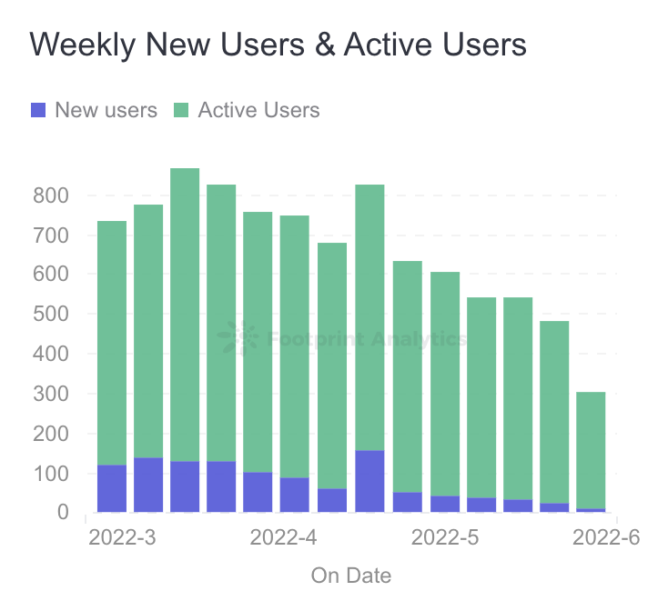

These are the very basic metrics to look at and understand and can directly get us information about the ongoing statistics of our product.

This is also the first part of our funnel i.e., getting users to join the platform.

* We want our business to grow so we always need to focus on increasing our user base actively.
* **If a company is in its growth phase the main goal can be increasing its user base and getting more people onboard.**
* We can modify our marketing strategy accordingly and for the onboarded customers we can create a notification system to encourage them to attend more classes/videos and make them more active on the platform.

1. **Retention table / Nth day retention (Engagement)**

* N-day retention simply measures how many of your users come back to your app on a particular day. We will start counting from “Day 0.”
* Day 0 could be the day that a free customer downloaded your app, or the paid customer made their transaction.

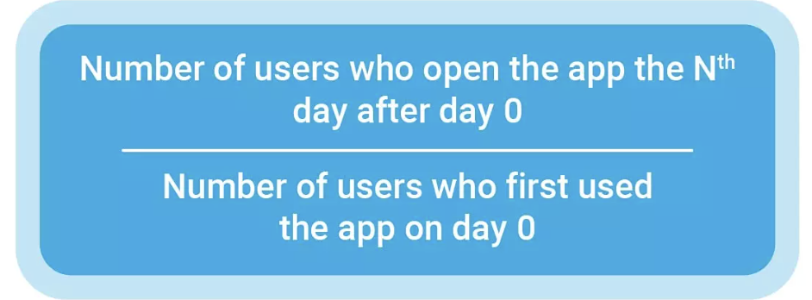

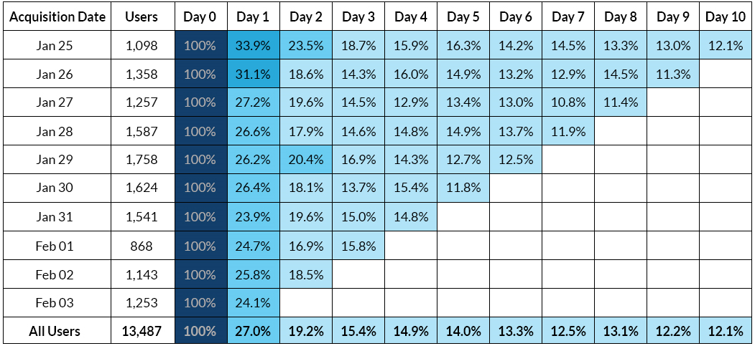

* The number of new users can be high but if the retention rate is not high, we will keep losing customers and eventually end up with a very small customer base.
* This will also give us feedback about the quality of our product or the stickiness of it.

1. **The number of classes attended / The duration of class attended (Engagement)**

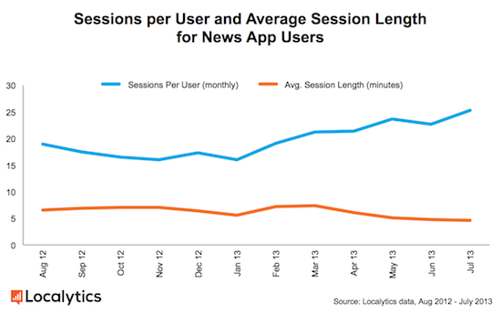

* For the engagement part, we can see the total number of classes attended by a user and their usage duration i.e., for how long the user was logged in.
* When exactly are they dropping off. For example, are they signing in and then just browsing and dropping off within 2-3 minutes. If yes, then that's feedback for us to improve our search and recommendations.
* If no. of users who attend the classes till the end is not too high, it probably means that the users are not liking the content that we are offering.
* We also need to understand what the desired level of interaction for each user is so that we can quantify and measure that it is below the desired level or around it like -
  + If it's at least once a day that's good.
  + If it's more than once a day that's super awesome.
  + If it's less than twice per week or maybe just once a week, then it's bad.

1. **Referrals and links shared / Feedbacks received**

* These may also help in understanding the level of love for the product that the customers have.
* For example, if a certain video or diet plan is shared by the users a lot with other people then we can easily identify that the people are loving it and finding it informative and useful.
* This is also important if we have a referral-based marketing strategy to onboard more people via connections and give them perks and discounts for it.
* If there is any feedback like - How was the session? How is the user communicating?
* Any sort of analysis on the feedback to understand what's going on with the user and trying to gauge whether the user will stay with us for more time or not.

**Q. Do we need to deep dive in any particular stage or reason?**

* We can look more into the content-based drop offs.

1. **Match rate between user and content (Engagement)**

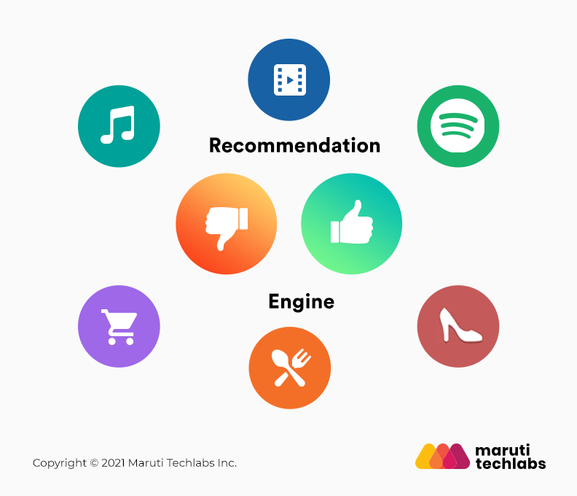

We can then look into the fact that why the user is dropping off from the class or what might be the reason for the user to not like the content.

* The very obvious reason can be the quality of the content, which we need to improve.
* The next most important thing to look at is if the user is getting what they need or they are looking for.
  + If a beginner user is looking for content of that level and is signed up for something that is very advanced for them, they will definitely be disheartened and will most likely drop off.
* It can also be a case that a person looking for Zumba is led to other activities such as yoga or weight training and they actually do not wish to do so.
  + We can have a feature inbuilt in the platform that can mark all classes and content based on different categories and segregate them for the users so that the users can actually understand the level and type of activity they are signing up for.
  + In addition to that we can bug the user upfront while signing up for understanding their intent and their expertise so that we can find and recommend a perfect match to them.

**NOTE:**

There are other metrics like free to paid user conversion percentage, that we would look at if the goal was to create a metric for success of the overall app, not just retention.

**CASE 2:**

Defining success for a banking application

________________________________________________________________

**Problem Statement**:

The “Indian Bank” which has been functional for the past 5 years and has an already established customer bank, just launched a new mobile application for its users.

**What are the success metrics you would set out to determine the success of the app?**

**Q. Do we need to look at the overall success of the bank or do we need to focus only on the success of the application?**

* We will focus on the success of the mobile app only.

Assuming that the bank is already set up and has a steady user base, we can think of two different aspects of the app, one for the new users and one for the existing ones.

The new users will have to follow an additional step of creating an account, assuming that is available via the application.

After this the funnel for user interaction and user journey will be the same for everyone i.e., different transactions and accessing different features available via the app link investments, fixed, recurring deposits loans etc., all depending on the services by the bank.

We will look into all of it, starting by dividing the metrics into two different sections:

* Revenue based metrics - because this is a bank we are looking at, the revenue is generated or directed through the mobile application itself.
  + That would help us understand the direct impact of the features and services we are providing to the users through the mobile application.
* The other aspect can be the overall user adoption or engagement.
  + This can also be categorized as non-revenue-based metrics which will help us understand if the app is user friendly and is fulfilling the expectations of the users.

1. **Revenue based metrics (Revenue) :**

To understand or calculate the revenue that the mobile app is generating, we first need to understand how the bank is itself making revenue.

We can list this information and also clarify if our information regarding the bank is valid or not.

* Credit card fees
* Checking accounts
* Savings accounts
* Mutual fund revenue
* Investment management fees
* Payment gateway fees

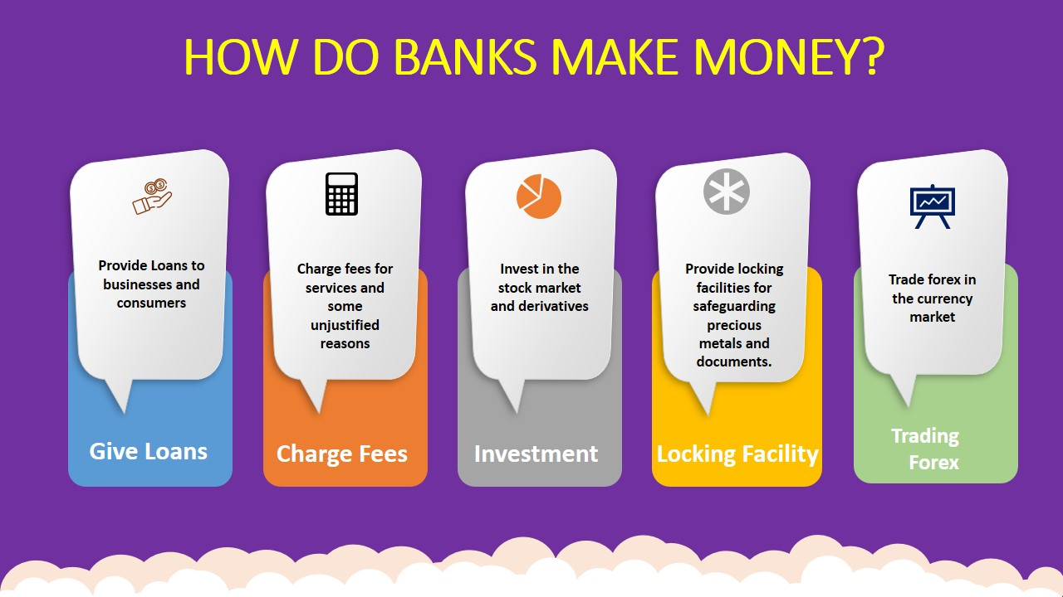

Now we can quantify out of everything what part of those revenue is being generated via the mobile app.

For example, in India, we use UPI payments and payment merchants like paytm/phonepay/gpay for payment at various places like while booking a ticket for movies via book my show website, you will be redirected to the payment application for final payment.

**Overall revenue increases due to less friction:**

There will be an increase in revenue due to ease of doing online payments and applying loans or doing investments.

Because the process has been made simpler and easier for the users, more users who did not use such features will now be a part of the increased revenue.

* For example, making payments via wallet/upi is much easier than internet banking, therefore increasing revenue.

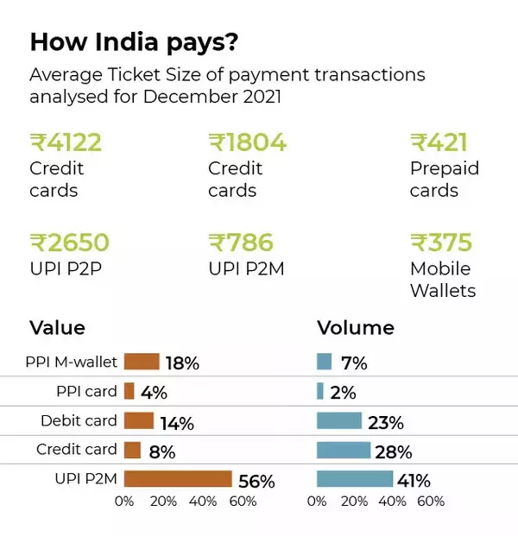

**Increase in revenue from the mobile application itself:**

For calculating the exact impact of the mobile application, we need to separate the existing revenue from the services and the revenue from the services from the mobile application. (We need to keep in mind that some of it may be cannibalized from other methods)

* We can target metrics like transactions per day, transactions per customer and total transaction value.
* We can also measure types of transactions, merchants, and purpose of the transactions to further understand and correctly take in account the type that we need for the calculation.

**Q. What percentage or ratio of transaction via mobile application would you be targeting for a successful mobile application assuming that the bank sees a shift in the industry to an online oriented one?**

* We could easily target somewhere around 80% of transactions and feature access for a successful transition of the bank to a mobile oriented goal.

1. **User adoption metrics (Adoption):**

To further understand the usage of the mobile application we need to understand the adoption of the mobile app by the users.

We can segment it into two parts:

1. Users who have ported to using mobile application.
2. New users that are joining via the mobile application.

* This will also help in future understanding the revenue that is being generated via the mobile application.
* We can measure the total mo. of accounts and the no. of accounts that are now opened via the application.
* This will enable us to understand how feasible it is and if the users are actually comfortable using the mobile application for such tasks.
* The ratio of this is what we should be looking to improve the adoption of the application for account opening and similar tasks like fixed deposits or investments, based on the services that the bank already provides.

1. **User Feedback and application records (Adoption) :**

* You need to have basic user feedback and metrics like Net Promoter Score (NPS).
  + Analyzing an organization's NPS is one of the best ways to understand the long-term growth of an organization.
* Doing sentiment analysis on user feedback would also be a great step in understanding the problems and users’ perspective about the app.
* Metrics like Abandon Rate are also really important. It is the percentage of users who started a given process within the app but did not complete it.
  + This metric helps measure how many users drop off during checkout and why they abandon their process.
* Task Completion Rate: This indicator helps to measure the user experience of a banking application.
  + It helps organizations gauge the rate at which the application solves the needs of its users.
  + Are users achieving their intended tasks? At what rate is that happening? Using this we can understand if the features of the application are failing.



